NAME: K Hemachandra
REG NO:192525234
COURSE CODE: CSA0603
CO-2 AT-3 : DEBUGGING AND OPTIMIZATION TASK

Debugging String Matching – Incorrect Loop Range
1. Error in the Given Code
The main error is in this line:
for i in range(len(text) - len(pattern)):
Python's range() excludes the ending value. Therefore, the last possible starting position of the pattern is not checked.
The correct loop is:
for i in range(len(text) - len(pattern) + 1):
Why does this happen?
Suppose:
text = "ABCDE"
pattern = "DE"
- len(text) = 5
- len(pattern) = 2
The given code executes:
range(5 - 2) = range(3)
So i takes:
0, 1, 2
But the pattern can also start at position 3:
A B C D E
D E
↑
Since position 3 is not checked, the valid match "DE" is missed.

2. Output of the Given Incorrect Code

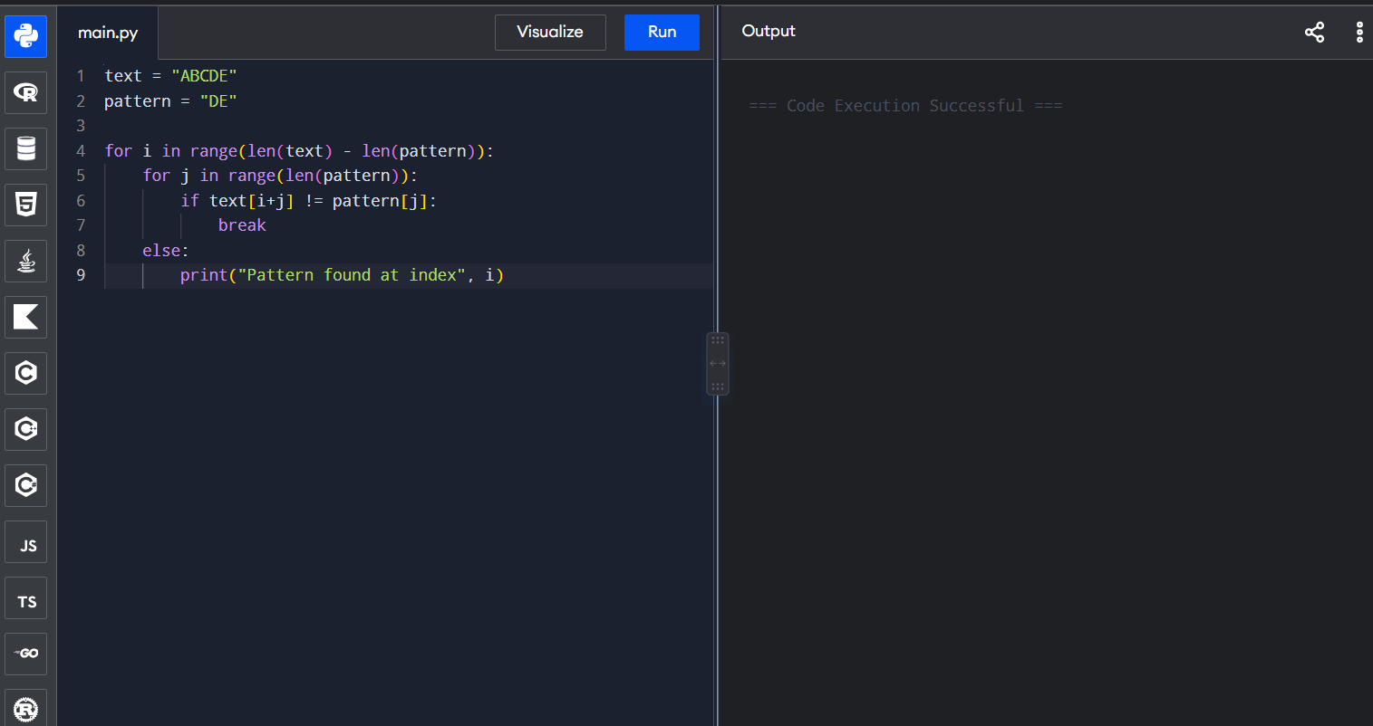

3. Problem in the Given Code
The main problem is the incorrect loop range in the outer loop:
for i in range(len(text) - len(pattern)):
The range() function does not include its ending value. Therefore, the last possible position where the pattern can occur is skipped.
Example
If:
text = "ABCDE"
pattern = "DE"
Then:
len(text) - len(pattern) = 5 - 2 = 3
So:
range(3)
checks only:
i = 0, 1, 2
But the pattern "DE" starts at index 3, which is not checked.
Correct Statement
for i in range(len(text) - len(pattern) + 1):

OUTPUT OF THE FOLLOWING CODE:

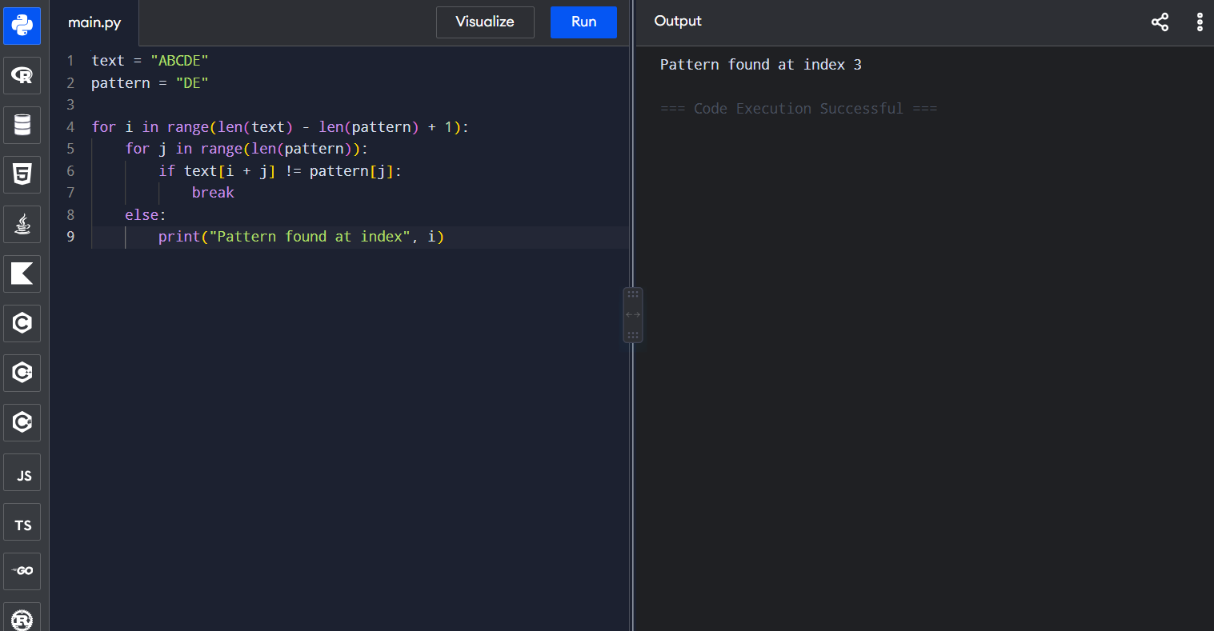

Optimizing Algorithm Efficiency
The brute-force string matching algorithm can be made more efficient by stopping the comparison immediately when a mismatch occurs. This avoids unnecessary comparisons.
Optimized Code

